**VAISHALI BOKADIYA**

**SQL CODING ASSESSMENT**

**QUESTION 1**

**Q1. a) Execute OVER and PARTITION BY Clause in SQL Queries**

Partition by is used to create row-wise partition in a table. It partitions the table into different parts according to the given criteria. PARTITION BY is used with OVER clause.

Example:

SELECT *,

COUNT(animalName) OVER () AS TotalAnimals,

COUNT(animalName) OVER (PARTITION BY gender ORDER BY animalName) as GenderCount

FROM animals;

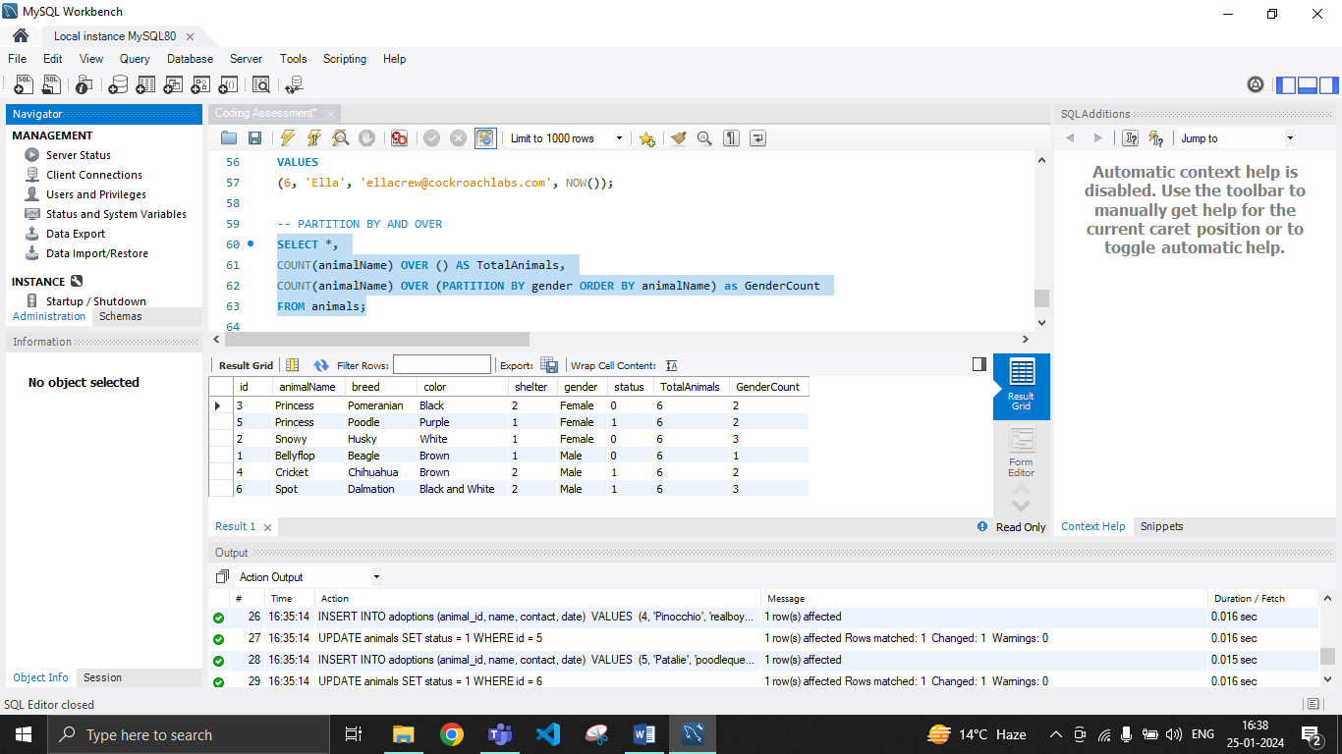

**Q1. b) Creating subtotals using SQL Queries.**

Subtotals in SQL can be created using ROLLUP.

EXAMPLE:

SELECT shelter, gender, COUNT(id) AS Count

FROM animals

GROUP BY

ROLLUP(shelter, gender);

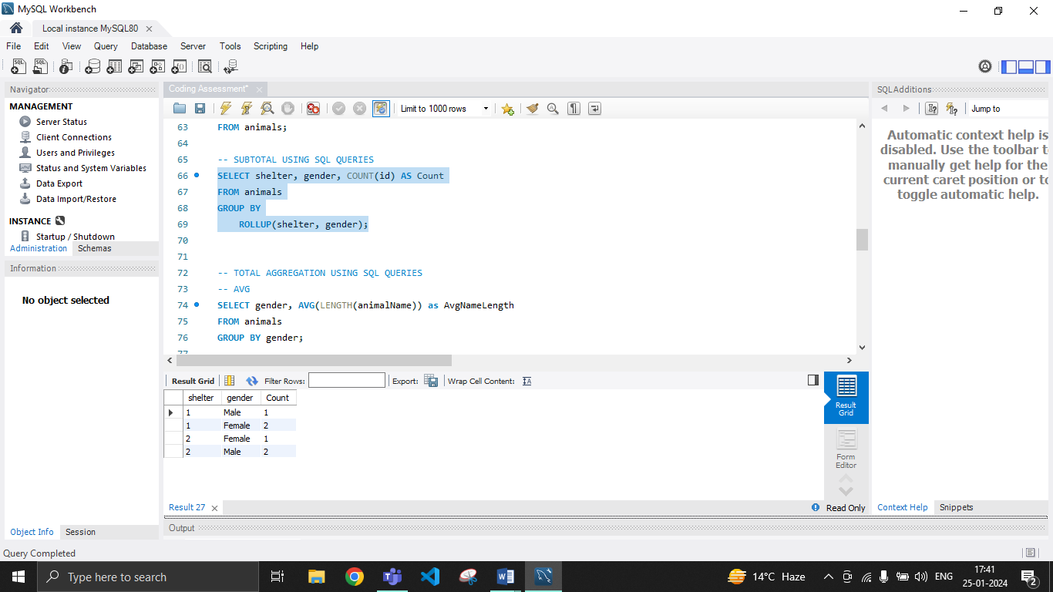

**Q1. c) Total Aggregations using SQL Queries.**

Total aggregation in SQL can be done using the following SQL functions:

* **AVG()**

AVG() in SQL is used to find the average of a particular attribute.

Example:

SELECT gender, AVG(LENGTH(animalName)) as AvgNameLength

FROM animals

GROUP BY gender;

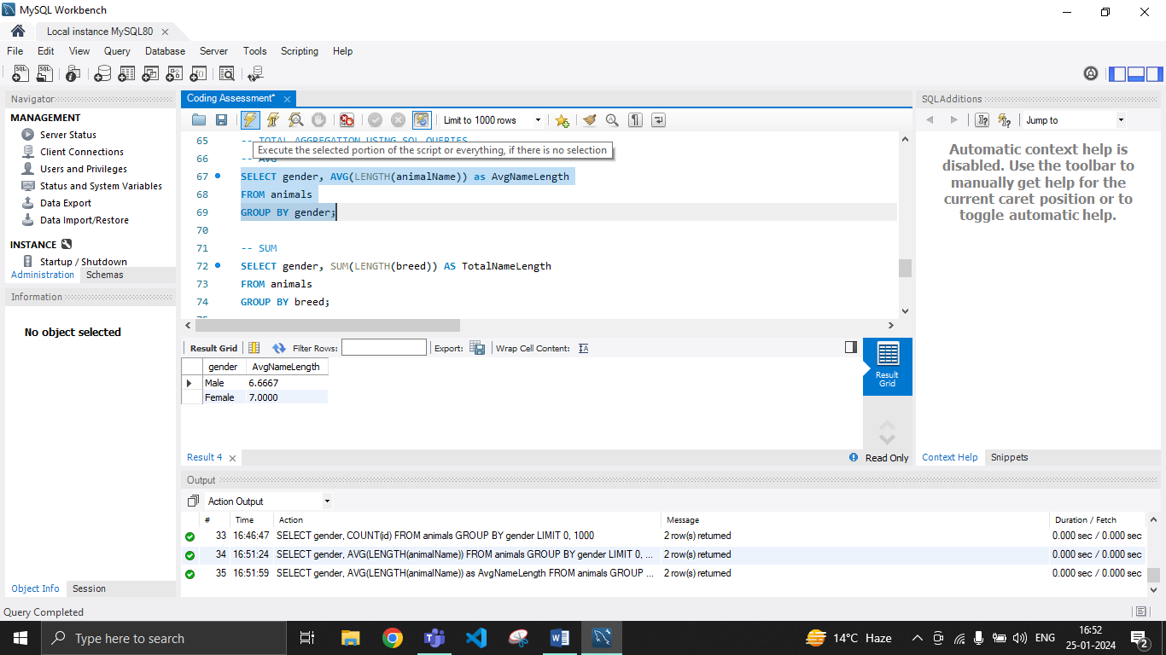

* **COUNT()**

COUNT in SQL is used to count the occurrence of a particular value in the column of the table.

Example:

SELECT gender, COUNT(id) as AnimalCount

FROM animals

GROUP BY gender;

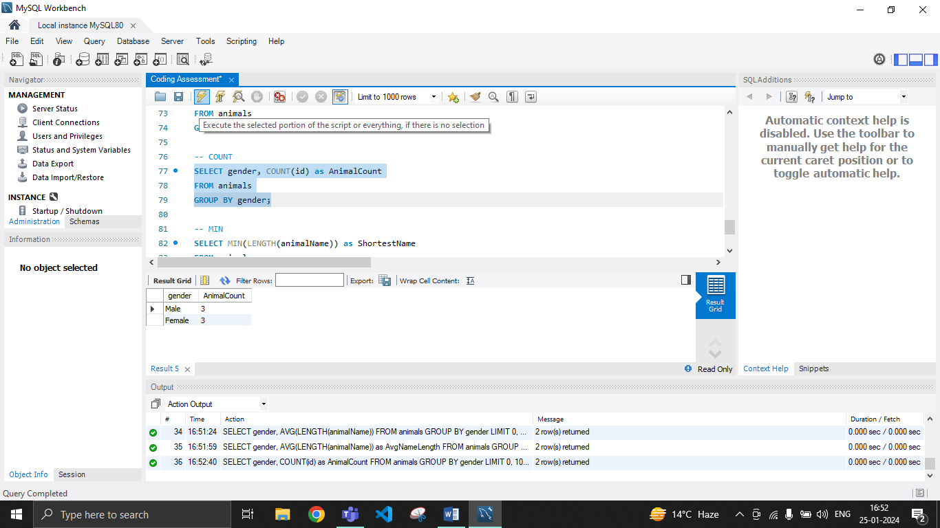

* **SUM()**

SUM in SQL is used to find the sum of a particular attribute of a table.

Example:

SELECT breed, SUM(LENGTH(breed)) AS TotalNameLength

FROM animals

GROUP BY breed;

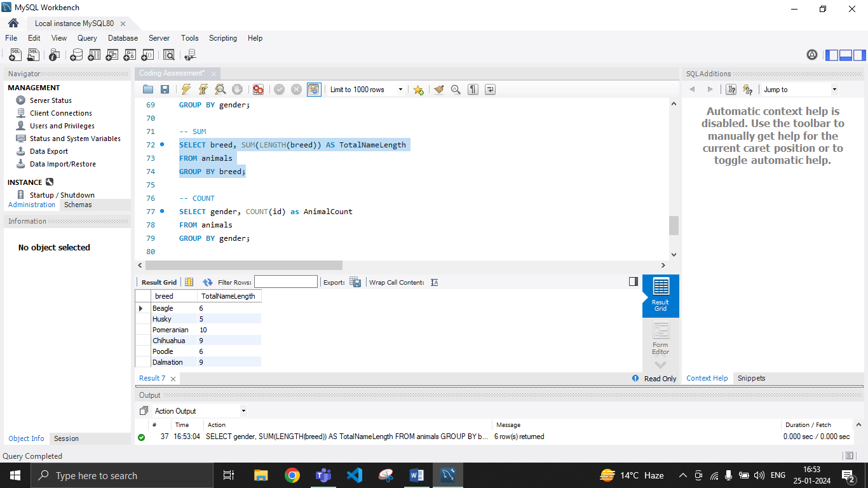

* **MIN()**

MIN in SQL is used to find the minimum (smallest) value in a particular column.

Example:

SELECT MIN(LENGTH(animalName)) as ShortestName

FROM animals;

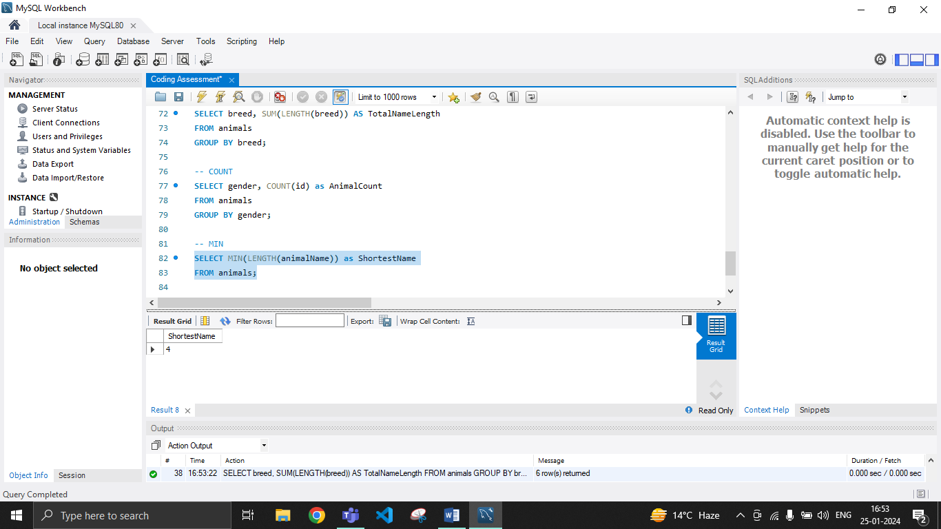

* **MAX()**

MAX in SQL is used to find the maximum (largest) value in a particular column in a table.

Example:

SELECT MAX(LENGTH(animalName)) as LongestName

FROM animals;

